**1. Certificates of Deposit (CDs)**

**2. Money Market Accounts**

**3. Individual Retirement Accounts (IRAs)**

**(Presented By Alan Stuart K)**

**1. Certificates of Deposit (CDs):**

**Introduction:**

Certificates of Deposit (CDs) are time deposits offered by banks and credit unions. They require the investor to deposit a fixed amount of money for a specified period, ranging from a few months to several years. In return, the bank pays interest at a fixed rate, which is generally higher than that offered by regular savings accounts.

**Insights:**

* **Interest Rates**: CD interest rates are typically higher than those of savings accounts because the money is locked in for a set period.
* **Safety**: CDs are considered low-risk investments because they are insured by the Federal Deposit Insurance Corporation (FDIC) up to $250,000 per depositor per bank.
* **Penalties for Early Withdrawal**: Withdrawing funds before the maturity date usually incurs a penalty, which can reduce the overall yield.

**Use Cases:**

* **Short-Term Savings Goals**: CDs are ideal for individuals who want to save for short-term goals and can afford to lock their money for a fixed period.
* **Risk-Averse Investors**: Investors looking for a safe place to park their money with guaranteed returns often prefer CDs.
* **Interest Rate Laddering**: Investors can use a CD laddering strategy, which involves purchasing multiple CDs with different maturities to maintain liquidity while maximizing interest earnings.

**Applications:**

* **Emergency Funds**: A portion of emergency funds can be placed in short-term CDs to earn higher interest while ensuring that funds are accessible when needed.
* **College Savings**: Parents saving for their children's education can use CDs to lock in interest rates and ensure the availability of funds when tuition payments are due.
* **Retirement Savings**: CDs can be part of a diversified retirement portfolio, providing a stable and predictable income stream.

**Data: Average Annual Percentage Yield (APY) for Certificates of Deposit:**

| **Year** | **1-Year CD** | **3-Year CD** | **5-Year CD** |
| --- | --- | --- | --- |
| **2015** | **1.10%** | **1.50%** | **2.00%** |
| **2016** | **1.20%** | **1.60%** | **2.10%** |
| **2017** | **1.35%** | **1.75%** | **2.25%** |
| **2018** | **1.50%** | **1.90%** | **2.40%** |
| **2019** | **1.60%** | **2.00%** | **2.50%** |
| **2020** | **0.55%** | **0.75%** | **0.95%** |
| **2021** | **0.60%** | **0.85%** | **1.10%** |
| **2022** | **1.50%** | **1.85%** | **2.20%** |
| **2023** | **4.25%** | **4.50%** | **4.75%** |
| **2024** | **3.75%** | **4.00%** | **4.25%** |

**2. Money Market Accounts:**

**Introduction:**

Money Market Accounts (MMAs) are a type of savings account that offers higher interest rates compared to traditional savings accounts. They often come with check-writing privileges and debit card access, making them more flexible.

**Insights:**

* **Higher Interest Rates**: MMAs typically offer higher interest rates than regular savings accounts due to higher minimum balance requirements.
* **Liquidity and Access**: MMAs provide easy access to funds through checks and debit cards, making them more liquid than CDs.
* **FDIC Insured**: Like CDs, MMAs are insured by the FDIC up to $250,000 per depositor per bank.

**Use Cases:**

* **Cash Reserves for Businesses**: Businesses can use MMAs to earn interest on their cash reserves while maintaining easy access to funds.
* **Savings with Accessibility**: Individuals who need to maintain liquidity but want to earn higher interest rates can use MMAs.
* **Emergency Funds**: MMAs are suitable for holding emergency funds due to their higher interest rates and liquidity.

**Applications:**

* **High-Interest Savings**: Savers looking to earn more on their deposits without losing access to their funds often choose MMAs.
* **Budget Management**: Individuals can use MMAs to segregate funds for specific purposes, such as vacation savings or major purchases, while earning interest.
* **Cash Flow Management**: Businesses can manage their cash flow efficiently by keeping funds in MMAs to earn interest until the money is needed for operational expenses.

**Data:** **Money Market Accounts:**

| **Year** | **Average APY** | **Average Balance** |
| --- | --- | --- |
| **2015** | **0.45%** | **$8,500** |
| **2016** | **0.50%** | **$8,800** |
| **2017** | **0.55%** | **$9,100** |
| **2018** | **0.60%** | **$9,400** |
| **2019** | **0.65%** | **$9,700** |
| **2020** | **0.35%** | **$9,500** |
| **2021** | **0.40%** | **$10,200** |
| **2022** | **1.25%** | **$11,000** |
| **2023** | **3.50%** | **$12,500** |
| **2024** | **3.25%** | **$13,800** |

**3. Individual Retirement Accounts (IRAs):**

**Introduction:**

Individual Retirement Accounts (IRAs) are tax-advantaged accounts designed to help individuals save for retirement. There are several types of IRAs, including Traditional IRAs and Roth IRAs, each with its own tax benefits and contribution limits.

**Insights:**

* **Tax Advantages**: Contributions to Traditional IRAs may be tax-deductible, and the earnings grow tax-deferred. Roth IRA contributions are made with after-tax dollars, but earnings grow tax-free.
* **Contribution Limits**: The IRS sets annual contribution limits for IRAs, which can change based on inflation adjustments.
* **Required Minimum Distributions (RMDs)**: Traditional IRAs require RMDs starting at age 72, while Roth IRAs do not have RMDs during the account holder's lifetime.

**Use Cases:**

* **Retirement Savings**: IRAs are a cornerstone of retirement planning, providing tax benefits and long-term growth potential.
* **Estate Planning**: Roth IRAs can be an effective estate planning tool, as they do not require RMDs and can be passed on to heirs.
* **Supplement to Employer-Sponsored Plans**: Individuals can use IRAs to supplement their employer-sponsored retirement plans, such as 401(k)s.

**Applications:**

* **Diversified Retirement Portfolio**: IRAs allow for a wide range of investment options, including stocks, bonds, mutual funds, and ETFs, enabling investors to build a diversified retirement portfolio.
* **Tax Planning**: Strategic use of Traditional and Roth IRAs can help individuals manage their tax liabilities during retirement. For instance, converting funds from a Traditional IRA to a Roth IRA in years of lower income can reduce future tax burdens.
* **Catch-Up Contributions**: Individuals aged 50 and older can make additional "catch-up" contributions to their IRAs, allowing them to save more as they approach retirement.

**Data: Individual Retirement Accounts (IRAs) - Average Contribution:**

| **Year** | **Traditional IRA** | **Roth IRA** | **Contribution Limit** |
| --- | --- | --- | --- |
| **2015** | **$4,200** | **$3,800** | **$5,500** |
| **2016** | **$4,300** | **$3,900** | **$5,500** |
| **2017** | **$4,400** | **$4,000** | **$5,500** |
| **2018** | **$4,500** | **$4,100** | **$5,500** |
| **2019** | **$4,600** | **$4,200** | **$6,000** |
| **2020** | **$4,800** | **$4,200** | **$6,000** |
| **2021** | **$5,100** | **$4,500** | **$6,000** |
| **2022** | **$5,400** | **$4,800** | **$6,000** |
| **2023** | **$5,700** | **$5,100** | **$6,500** |
| **2024** | **$6,000** | **$5,400** | **$6,500** |

**Graphs:**

**Graph 1:** 10-Year Treasury Rate (Proxy for CDs Interest Rates) – Closing Price:

#### 

#### Inference: The closing price graph of the 10-year Treasury Rate provides a clear view of the trends in long-term interest rates over time. An upward trend indicates rising interest rates, which translates to higher potential returns for new CDs. Conversely, a downward trend signals falling rates, leading to lower returns on CDs. This graph helps investors understand the interest rate environment and make informed decisions about locking in rates with CDs.

#### Graph 2: SPDR Bloomberg Barclays 1-3 Month T-Bill ETF (Money Market Proxy) – Rolling Mean and Std Dev:

#### Inference: The rolling mean and standard deviation for the SPDR Bloomberg Barclays 1-3 Month T-Bill ETF illustrate the ETF’s average price and volatility over a specific period. A stable rolling mean suggests consistent price levels, while a low rolling standard deviation indicates minimal price fluctuations. This low volatility is characteristic of money market accounts, highlighting their role as low-risk, stable investment options with relatively predictable returns.

**Graph 3:** Vanguard Target Retirement 2030 Fund (IRA Proxy) – Daily Returns Distribution:

#### Inference: The daily returns distribution for the Vanguard Target Retirement 2030 Fund shows how frequently various daily returns occur. A normal distribution centred around zero suggests typical market behaviour, with most daily returns near the average and fewer extreme changes. This graph helps investors understand the day-to-day volatility and risk associated with the fund, which is crucial for those planning long-term investments in IRAs.

**Graph 4:** Vanguard Target Retirement 2030 Fund (IRA Proxy) – Monthly Returns Distribution:

#### 

#### Inference: The monthly returns distribution provides insight into the fund's performance on a month-to-month basis. A wide range of returns indicates higher variability and potential for both gains and losses, while a tighter range suggests more stable monthly performance. Understanding this distribution helps investors anticipate the potential fluctuations in their retirement fund’s value and better manage their long-term financial planning.

**Graph 5:** 10-Year Treasury Rate (Proxy for CDs Interest Rates) – Cumulative Returns:

#### Inference: The cumulative returns graph for the 10-year Treasury Rate shows the overall return accumulated over time. Positive cumulative returns reflect an increase in interest rates, benefiting new CD investments with higher yields. Negative cumulative returns, on the other hand, indicate a decline in rates over the period. This graph is essential for investors looking to understand long-term trends in interest rates and how they impact the attractiveness of CDs.

**Graph 6:** Correlation Heatmap of Financial Instruments:

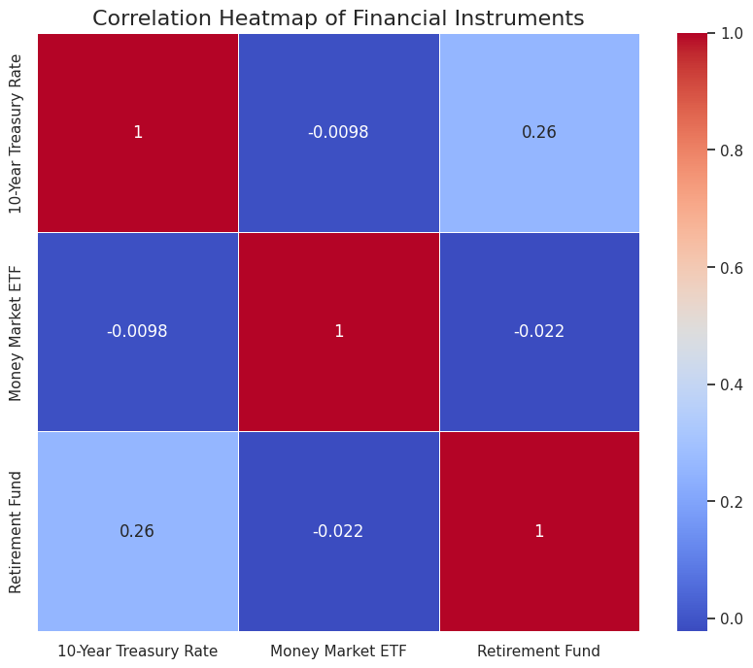

**Inference:** The correlation heatmap illustrates the relationships between the daily returns of different financial instruments. High positive correlations indicate that the instruments tend to move in the same direction, while high negative correlations suggest they move in opposite directions. Low or zero correlations imply little to no relationship. This analysis is critical for portfolio diversification, helping investors spread risk by combining assets that do not move in sync.

**Graph 7:** Vanguard Target Retirement 2030 Fund (IRA Proxy) – Annual Returns:

#### Inference: The annual returns graph shows the year-over-year performance of the Vanguard Target Retirement 2030 Fund. Consistent positive returns indicate steady growth, which is ideal for long-term retirement savings. Negative returns in certain years highlight periods of market downturns or volatility affecting the fund’s performance. This graph helps investors evaluate the fund's historical performance and its alignment with their retirement goals.

**Graph 8:** Vanguard Target Retirement 2030 Fund (IRA Proxy) – Cumulative Returns:

#### 

#### Inference: The cumulative returns graph depicts the total compounded returns of the Vanguard Target Retirement 2030 Fund over time. A steadily increasing curve indicates continuous growth, reflecting successful long-term investment performance. Any periods of flattening or decline highlight times of market stagnation or loss. This visualization helps investors assess the overall growth trajectory of their retirement savings.

**Graph 9:** Vanguard Target Retirement 2030 Fund (IRA Proxy) – Rolling Mean and Std Dev:

#### Inference: The rolling mean and standard deviation for the Vanguard Target Retirement 2030 Fund provide insights into the fund's average performance and volatility over time. A steady rolling mean with low standard deviation indicates consistent performance with minimal volatility, aligning with the goals of a retirement fund that seeks stable and reliable growth. This analysis helps investors understand the fund’s risk and return characteristics in different market conditions.

**Conclusion:**

These three financial instruments - CDs, Money Market Accounts, and IRAs - each serve distinct purposes in a comprehensive financial strategy, catering to different risk tolerances, time horizons, and financial goals. CDs offer guaranteed returns and are ideal for short to medium-term savings goals, albeit with limited liquidity. Money Market Accounts provide a balance of higher interest rates and accessibility, making them suitable for emergency funds or temporary cash holdings. IRAs, whether Traditional or Roth, are crucial long-term savings vehicles with significant tax advantages, forming the backbone of many retirement plans. When used strategically, these tools can work in concert to help individuals build a robust financial foundation, manage risk, optimize returns, and work towards both short-term financial stability and long-term retirement security. The key to maximizing their benefits lies in understanding each instrument's unique features and aligning them with personal financial objectives and circumstances.